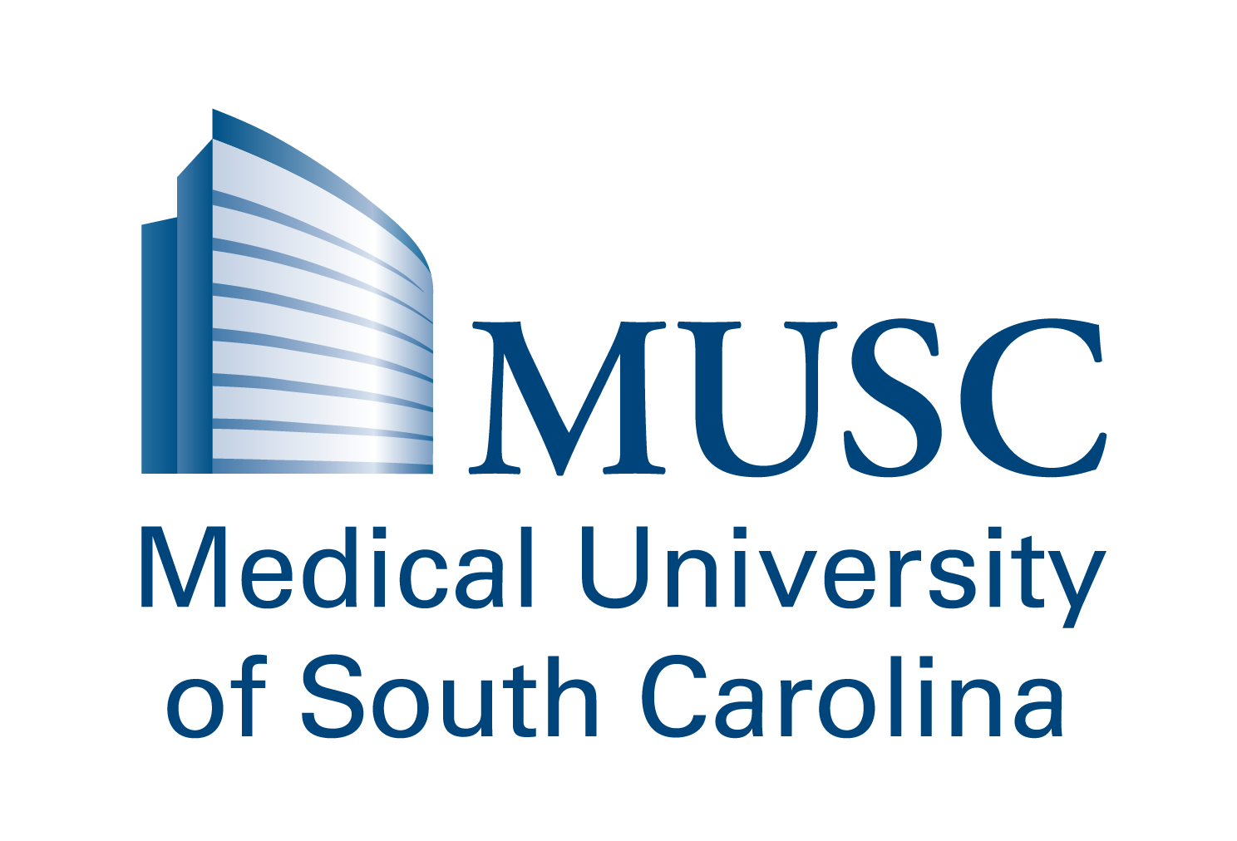
The James B Edwards College of Dental Medicine XXIII Annual Continuing Education Course
The Dr. Carlos F. Salinas Dental Program for the Diagnosis and Treatment
Of Individuals with Special Health Care Needs
MARRIOTT NORTH CHARLESTON
Friday, September 30, 2022
8:00 a.m. – 4:00 p.m.

Attendee Information: (one registration form per person)

Name:_________________________________ Degree: _____________

Address:_____________________________________________________________________________

City: _________________________________________ State: ________ Zip Code:_________________

Telephone:_____________________________ Email________________________________________

The MUSC JBE College of Dental Medicine is an ADA CERP recognized provider. ADA CERP is a service of the American Dental Association to assist dental professionals in identifying quality providers of continuing dental education. ADA CERP does not approve or endorse individual courses or instructors, nor does it imply acceptance of credit hours by boards of dentistry. The MUSC JBE College of Dental Medicine designates this activity for 7.0 hours of continuing education credits. The objective of this course is to provide current oral health information about patients with special needs to the dental professionals in SC. With this collaboration, our goal is the reduction of oral health disparities and achieving a better quality of life for this special and very vulnerable segment of our population. It will offer a combination of lectures, visual presentations and Q&A sessions.

Registration:
□ Dentists, MD, Ph.D. - $200.00
□ Retired dentist - $200.00
□ Dental hygienist, other health professionals - $150.00
□ Non-MUSC CDM Residents or Students - $150.00
□ MUSC CDM Faculty, Residents, and Students - $100.00
□ I would like to sponsor a student to attend - $100.00
□ I would like to make a onetime donation to the program in memory of Dr. Carlos Salinas $_____________
*Fee includes breakfast, lunch buffet, and 7 CE Credit Hours.

Total amount enclosed $________________

If you are paying by check, please make checks
Questions:
If you need additional information, including
cancellation policy, contact Brooke Trevino.
trevinob@musc.edu
843-792-1911
payable to “MUSC Foundation” and mail to the
below address:

Salinas Seminar
Attn: Brooke Trevino
Medical University of South Carolina
James B. Edwards College of Dental Medicine
173 Ashley Ave, BSB 500A, MSC 507
Charleston, SC 29425-5070

